**CLOUD ACCOUNT CREATION**

|  |  |
| --- | --- |
| **TEAM ID** | **PNT2022TMID24852** |
| **PROJECT TITLE** | **IoT BASED SMART CROP PROTECTION SYSTEM FOR AGRICULTURE** |
| **DATE** | **27 OCTOBER 2022** |

We need to have basic knowledge of the following cloud services:

• IBM Watson IoT Platform

• Node-RED Service

• Cloudant DB

We need to create an IBM Cloud Account to complete this project.

**LOGIN:**

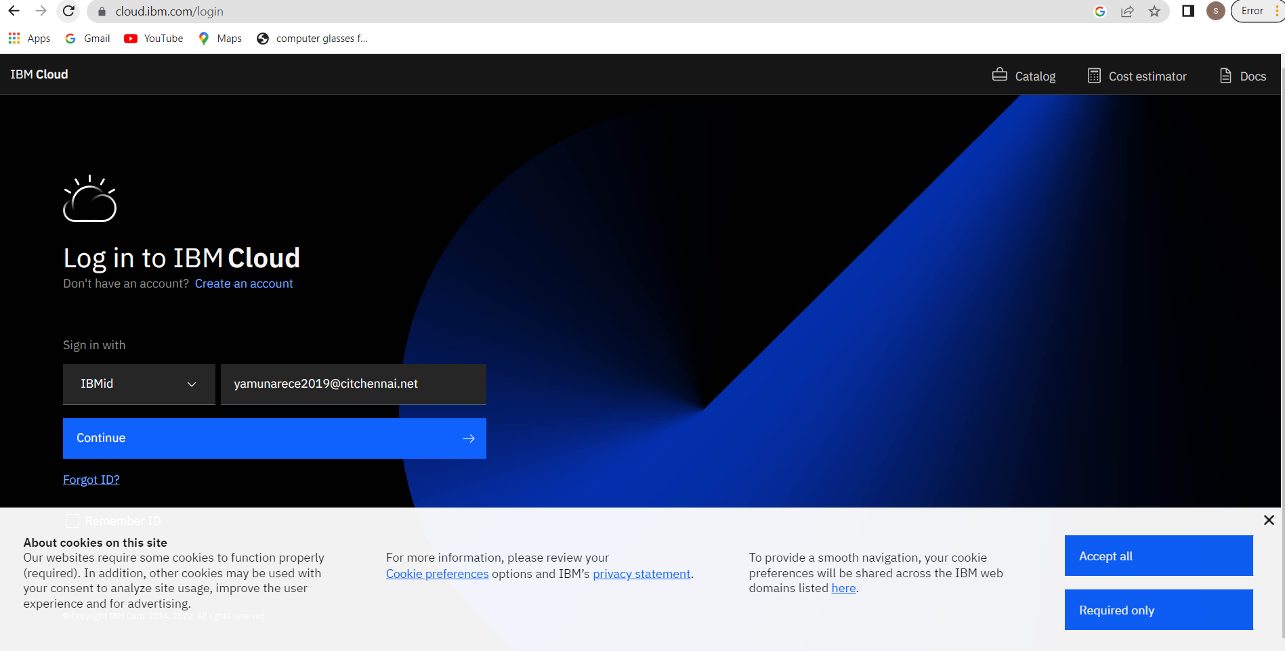

**DASHBOARD:**

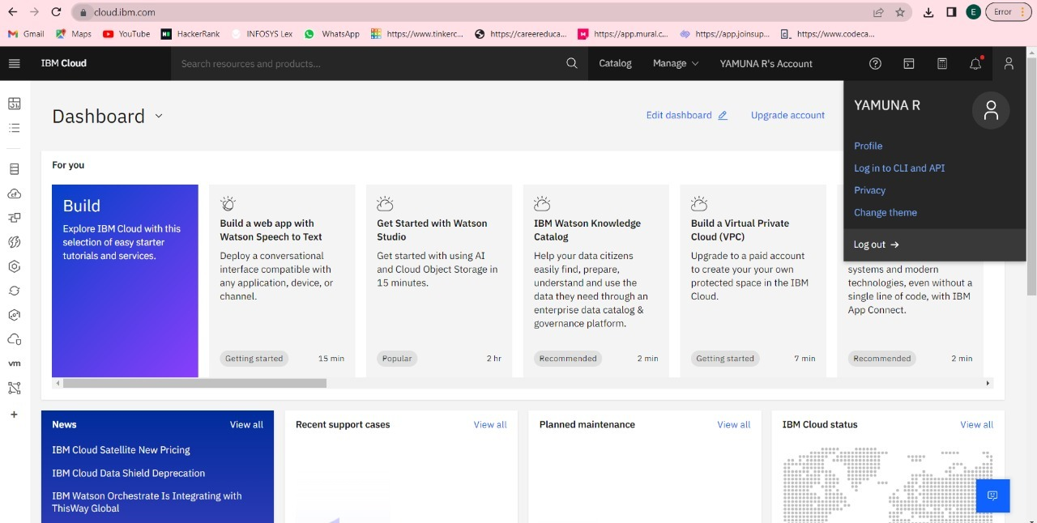

**ACCOUNT SETTINGS:**

